**Project Design Phase-I**

**Solution Architecture**

|  |  |
| --- | --- |
| Date | 22/10/2022 |
| Team ID | PNT2022TMID12375 |
| Project Name | AI-based localization and classification of skin disease with erythema |
| Maximum Marks | 4 Marks |

**Solution Architecture:**

Solution architecture is a complex process – with many sub-processes – that bridges the gap between business problems and technology solutions. Its goals are to:

* Find the best tech solution to solve existing problems.
* Describe the structure, characteristics, behavior, and other aspects of the software to project stakeholders.
* Define features, development phases, and solution requirements.
* Provide specifications according to which the solution is defined, managed, and delivered.

**Example - Solution Architecture Diagram:**

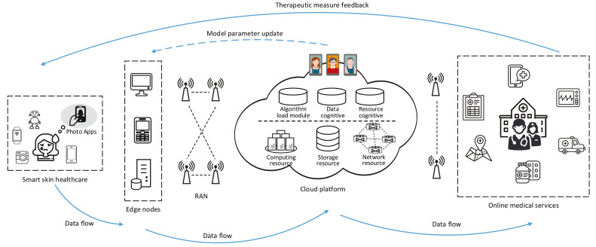

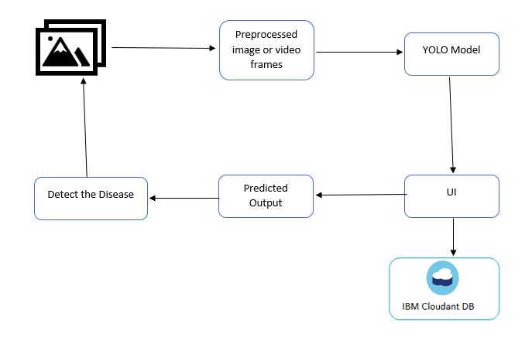

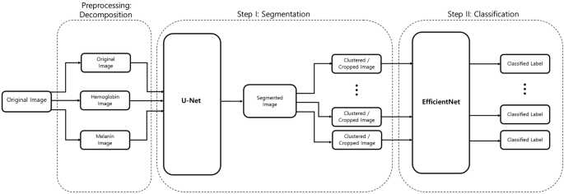

**Reference:**

<https://www.google.com/url?sa=i&url=https%3A%2F%2Fcareereducation.smartinternz.com%2Fsaas-guided-project%2F3%2Fai-based-localization-and-classification-of-skin-disease-with-erythema-59&psig=AOvVaw2VI1tcmkfCXx-g2kKvI4Qg&ust=1666537463153000&source=images&cd=vfe&ved=0CBAQ3YkBahcKEwjg6KWAjvT6AhUAAAAAHQAAAAAQBA>